Lesson plan:
Resilient Designs
adapted from the lesson “3, 2, 1…Natural Disaster” by the Oak Ridge Institute for Science and Education

Cultural Relevance:
South Dakota Oceti Sakowin Essential Understandings
1: Lands & Environment
Standard 1.4: Demonstrate understanding of the traditional and contemporary interrelationships of the Oceti Sakowin Oyate with respect to places, environment, and geography.
Standard 1.6 – Examine strategies the tribal governments and other tribal leaders are taking to improve the lands and natural gifts of Oceti Sakowin people.
7: Way of Life and Philosophy
Standard 7.3 Demonstrate how the people are continuing to promote an Oceti Sakowin way of life.
Standard 7.4 Use Oceti Sakowin philosophy to problem-solve concepts and tackle unfamiliar challenges.
Target Grade: 6th Science
Middle School Earth and Space Science Standards
MS-ESS3-3 Analyze and interpret data on natural hazards to forecast future catastrophic events and inform the development of technologies to mitigate their effects. (ND ESS3-2; SD MS-ESS3-3)
Grades 6-8 Engineering Design Standards
6-8-ETS1-1 Define the criteria and constraints of a design problem with sufficient precision to ensure a successful solution, taking into account relevant scientific principles and potential impacts on people and the natural environment that may limit possible solutions. (ND MS-ET1-1; SD 6-8-ETS1-1)

Science and Engineering Practices
Asking Questions and Defining Problems
Constructing Explanations and Designing Solutions
Lesson Objectives:
Students will:
- Design and construct model shelters built to withstand a given severe weather event following the design constraints.
- Assess shelters through a test to evaluate the shelter’s resilience, focusing on its ability to withstand the given weather event.
- Engage in scientific discourse, answering and asking questions.
- Make connections throughout the lesson to the Oceti Sakowin Essential Understandings.

Oceti Sakowin Essential Understandings connections:
This lesson provides students with opportunities to learn the value of fortitude, what it means to be courageous and work with community to look for solutions. This value is highlighted in the OSEU Way of Life and Philosophy, Standard 7.4. Students will reflect on how they practice this standard as they works together to build their resilient home. Standard 7.3 is celebrated in the work of Red Cloud Renewable. Students learn more about this project in this lesson and have opportunities to reflect on communities working together for the good of the community.
Additionally, this lesson connects to the Oceti Sakowin Essential Understanding, Land and Environment. Throughout the lesson, in the videos, reflections, and student discussions, students have opportunities to learn about Oceti Sakowin relationship to place and community (OSEU 1.4) and to through ways in which the people are leaders are making strides to improve the land (OSEU 1.6).

Central Focus:
This engaging lesson gives students a chance at an authentic use of engineering design. Students are tasked to build a house that can withstand a given severe weather event. Students engage in designing, building, testing, collecting data, and improving shelters. Students not only use engineering practices but learn about weather events as well.
Key words: science, engineer, test, weather, shelter, revise, brainstorm, solution, prototype, process, present

Engineering Design Process:
Students should be aware of the engineering design process prior to this lesson. Although there are different variations, the steps we will use include the following: Define the Problem, Collect Information, Brainstorm Solutions, Develop a Solution, Build a Prototype, Present Your Ideas to Others for Feedback, Test and Redesign. The process is never really complete, as there can always be additional redesign.

Length of Activity: Three class periods, 45-60 minutes- more time may be preferred.
Core Problems/Outline of the Lesson
Introduction- Student reflection on meaning of fortitude
Hook- Meteorology report
Engage- design resilient home (if spanning over three periods- this is a good break)
Explore- build resilient home (one period to build)
Explain- testing of resilient home (begin third class period with finishing the build and testing procedures)
Final closure- revisit fortitude
Materials:
- Lesson PowerPoint
- Fortitude quotes- handout
- Task cards
- Chart paper/markers
For building:
- 6” x 6” pieces of cardboard (1 per team)- This is the only required supply for building materials.
Suggested materials for building:
- rulers
- hot glue gun
- duct tape (12” per team)
- rubber bands
- paper clips
- string
- cardboard
- plastic cups
- plastic wrap
- clay
- construction paper
- plastic straws
- masking tape
- bubble wrap
- liquid glue
- foam sheets
- craft sticks

For testing:
- 150 mL beaker (2)
- gallon-sized plastic tubs (3)
- foil pans
- portable vacuum cleaner
- blow dryer
- 6 c. muddy water with gravel
- 1 foot x 1 foot piece of cardboard (2)
- heat lamps (2)
- thermometers (4)
- watering can
- clay
- frozen peas
- ice cubes
- ball bearings

Suggested Lesson Activity
Preparations before class:
It works best to have one long table with all of the building materials displayed for students to see when they are planning the design of their home. Have all of these materials displayed before class begins.

Day 1: Plan
Opener: Warm up/Bell ringer- As students come into class display the slide with a map of the United States- with regions, and images of houses.
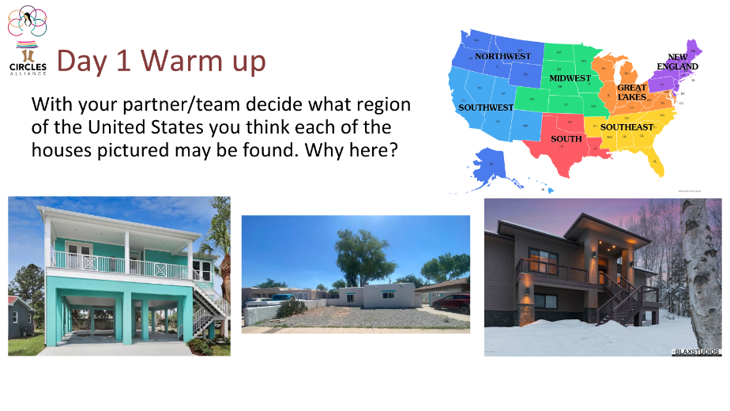
Students will work with their partner or team to determine where they think each of these homes can be found and why.
There are no “right” answers as long as students can provide justification.
House 1- Students may notice this house is elevated- to help in times of flooding.
House 2- Students may notice the materials this house is made of could help keep the house cool in hotter temps and has very little landscaping.
House 3- Students may notice this house is also elevated- but perhaps for different reasons than house 1.
Provide time for students to discuss and share their thoughts in small groups and then share with the whole class.
Share with students they will be exploring weather events and making their own design decisions to build houses that will withstand these events.

Instruction:
You can start this lesson showing students the word for Fortitude in Lakota- WOWAČÍŊTAŊKA.

The linked video is from the Tribal Education Virtues site. In it, Duane Hollow Horn Bear pronounces Wowačíŋtaŋka.
Although the video states this virtue is Patience and Self-Control, you may choose to show this video so that students can hear the pronunciation AND the perspective of these elders.

Display the following quote:
FORTITUDE – WOWAČÍŊTAŊKA
Fortitude means facing danger or challenges with courage, strength, and confidence. Believing in oneself allows a person to face challenges. Fortitude includes the ability to come to terms with problems, accept them, and to find a solution that is good for everyone.
- from Lakota Value Akta Lakota St. Joseph Indian School

Have students independently reflect and journal using the following questions as a guide:
What is standing out to you as you read this?
What actions do you connect with fortitude?
What connections can you make with your own life?
“We are now going to share a scenario during which the value of fortitude would be helpful.”
After students privately reflect in their notebooks about this quote, have the share with a partner or with their table teams.

Hook:
Role play the following scenario to engage students: “The Earth’s weather patterns are changing. Meteorologists across the country have reported that communities should prepare for increased extreme weather events! As a community, we will need to design shelters that are more resilient to these weather events so our society is more climate resistant.”

Build Background: The Earth is being impacted by climate change, resulting in more frequent extreme weather events and natural disasters. These events impact communities across the country. People can lose their homes due to floods, blizzards, tornadoes, and other forms of extreme weather.

Teacher prompt: After reading the Hook and the Build Background paragraph above ask students:
- Why would fortitude be important when communities face difficult weather events, such as floods, blizzards or tornadoes?
Provide a few moments of think time for students to reflect on this question. Then ask students to share with a partner, or at tables. During this share time, allow time and space for all students to have opportunities to share if they would like.
During this time, teachers can listen to small groups and ask students if they might feel comfortable sharing with the whole class.
After providing time for students to share in small groups, ask if anyone would like to share with the class.
- How does working together to solve problems help a community stay strong?
Provide a few moments of think time for students to reflect on this question. Then ask students to share with a partner, or at tables. During this share time, allow time and space for all students to have opportunities to share if they would like.
During this time, teachers can listen to small groups and ask students if they might feel comfortable sharing with the whole class.
After providing time for students to share in small groups, ask if anyone would like to share with the class.
The Oceti Sakowin are community problem-solvers. Throughout time and today they work together with those around them to build relationships and to think strategically and to collaboratively come up with problems to help one another and overcome challenges.
Oceti Sakowin Essential Understanding #7, Way of Life and Philosophy says,
“The essential philosophy of the Oceti Sakowin wicoun (way of life) is based on the values of the Oceti Sakowin which support a thriving, prosperous, and flourishing Oyate (people).”
As you work in this lesson you are going to practice this way of life, working together to overcome a challenge.

Divide students into 'teams’ of 4-6 and provide each group with the Meteorology Report for their ‘region.’ Instruct students to read the reports themselves and highlight the information in the reports pertaining to the impact the severe weather has on shelters, focusing on cause (quantitative facts related to the event’s speed, size, and duration) and effect (impact on shelters).
Before students get started remind them that with their team they are a community of problem solvers.

Engage
Task Explanation: Provide a Building Task Card to each group and explain to students that it is their job to work as a team of engineers and architects to build a shelter that can withstand their given severe weather event. Explain that they will all be designing for different weather events to collectively make our society more climate resistant. Their goal is to create a shelter with the most protection they can design. Discuss the constraints for the structures. Share the Testing Procedures with each group.

Active Learning: Have groups peruse the supplies available for building their shelters. Students draw their shelter on a sheet of poster paper as they plan to build it. They label it with the weather event the shelter is designed to protect against. They also label each design element they will include and the materials they will use to construct the shelter. Before teams build, they must have their plan approved by the building inspector (teacher).
This is a good ending for the first day of the lesson.
Let students know they will start on day two building their resilient home.

Closing for Day 1:
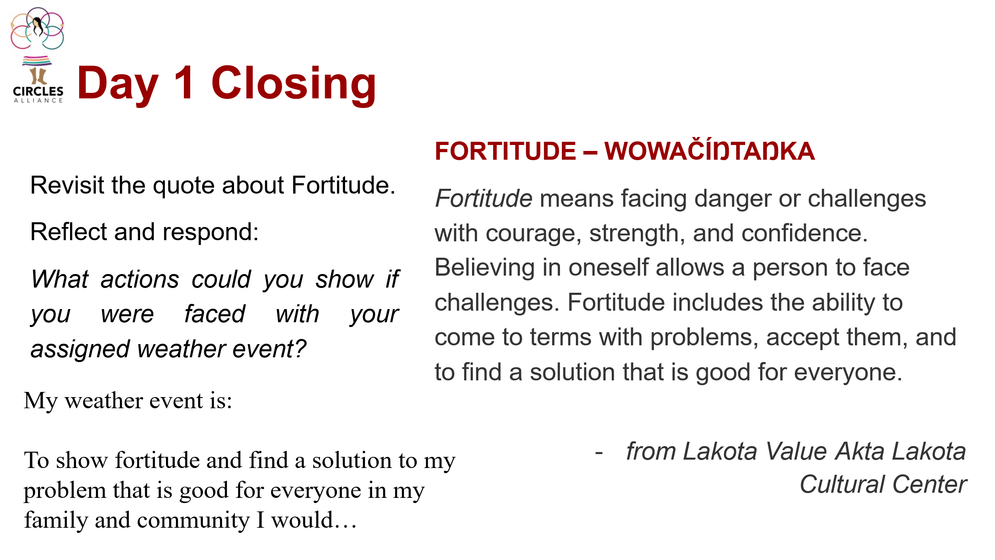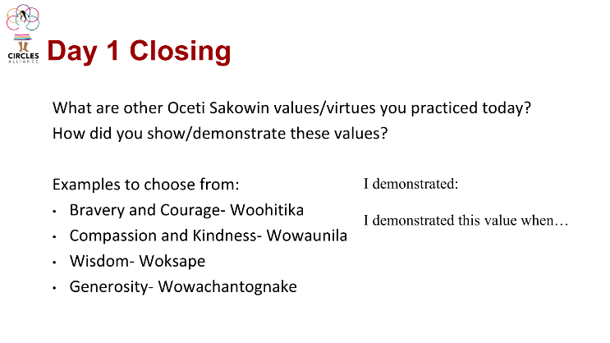

Return to the quote on fortitude.
Ask students to reflect on and respond to the question:
- What actions could you show if you were faced with your assigned weather event?
For example, if you were assigned the weather event of a flood, what actions could you demonstrate to find a solution that is good for you, your family and your community?
- What are other Oceti Sakowin values and virtues you practiced today? How did you show these?
You may choose to have students complete this reflection as an exit ticket.
Students will select their building materials in Day 2- If possible- Keep these supplies displayed.

Day 2: Build
Preparations before class:
Students will select their building materials today. Have all the building materials out for students to choose from before class begins. **If students choose duct tape- have 12” pieces pre-cut for students**

Opener: Warm up/Bell ringer- As students come into class display the slide asking them to choose which Oceti Sakowin value they will focus on as they build their home today:
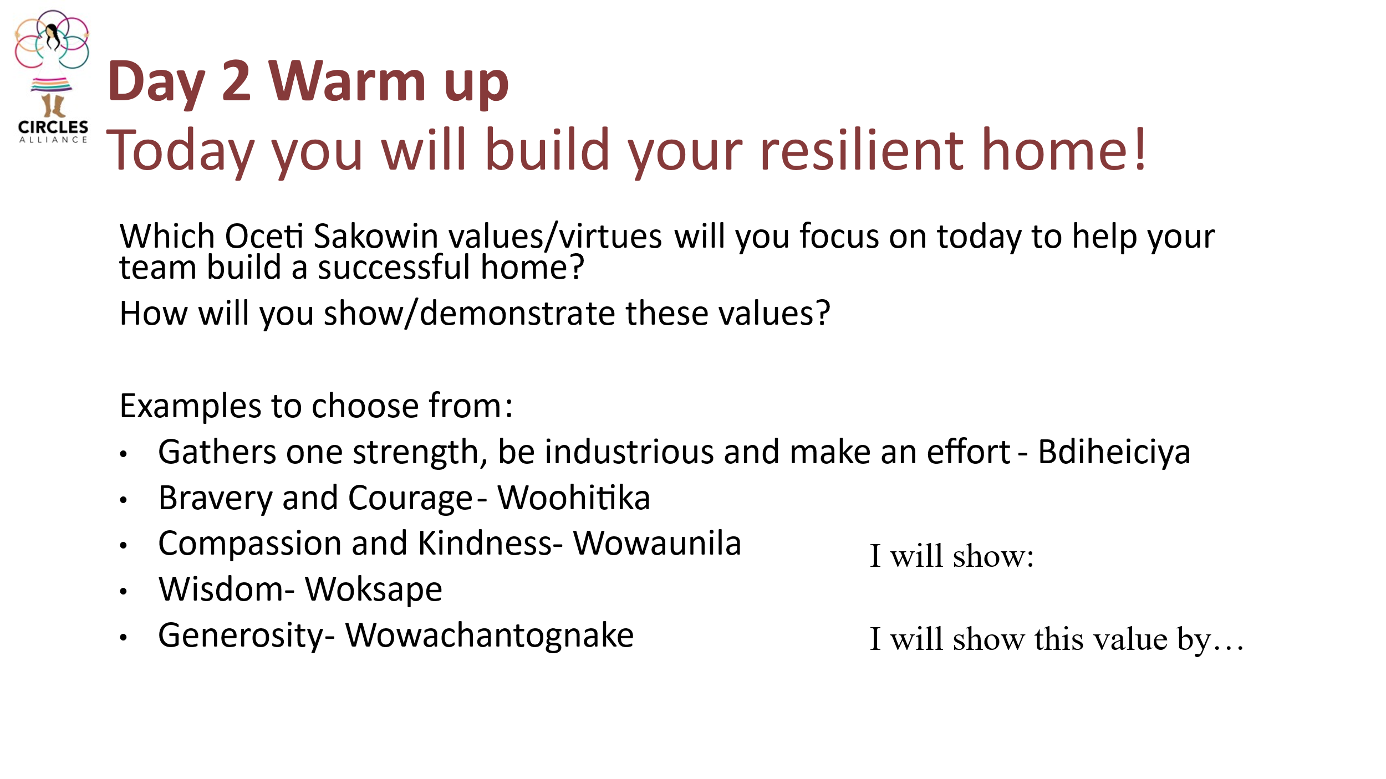
Before students begin to build provide them time in teams to determine team roles. Who will gather materials? Who will build? Each team member needs to be active in the day AND practice their chosen value/virtue from the warm up.
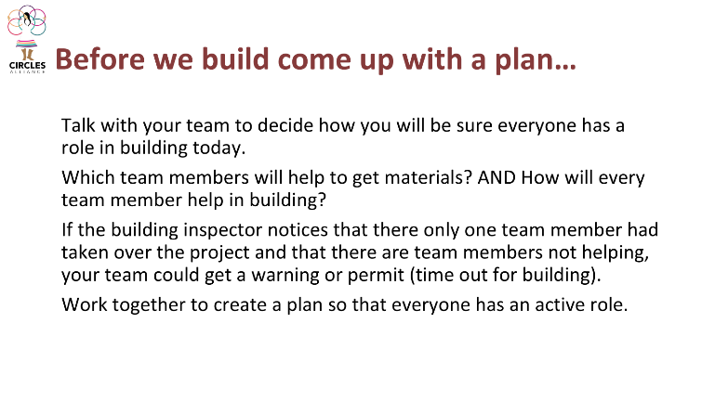
Allow time for teams to share- so that every team hears others’ ideas.

Before teams begin to build, they will watch a short video highlighting the Red Cloud Renewable Energy project from SD PBS. The intent of this video is to show students current building practices used in Pine Ridge, South Dakota showing innovation! As students watch the video ask them to look for examples of Oceti Sakowin Essential Understandings Land and Environment and Way of Life and Philosophy. See slides for student reflection questions
Oceti Sakowin Essential Understanding 1 Land and Environment:
The original land base and natural resources of the of the Oceti Sakowin were part of communal stewardship. Oceti Sakowin have a distinct and unique interrelationship with the environment.
Standard 1.4: Demonstrate understanding of the traditional and contemporary interrelationships of the Oceti Sakowin Oyate with respect to places, environment, and geography.
Standard 1.6 – Examine strategies the tribal governments and other tribal leaders are taking to improve the lands and natural gifts of Oceti Sakowin people.

Oceti Sakowin Essential Understanding 7 Way of Life and Philosophy:
The essential philosophy of the Oceti Sakowin wicoun (way of life) is based on the values of the Oceti Sakowin which support a thriving, prosperous, and flourishing Oyate (people). Tribal communities have put considerable effort into pedagogy, early education and economic development, Tribal universities and colleges, wellness centers, cultural traditions, and language growth and expansion.
Standard 7.3 Demonstrate how the people are continuing to promote an Oceti Sakowin way of life.
Standard 7.4 Use Oceti Sakowin philosophy to problem-solve concepts and tackle unfamiliar challenges.
Students will reflect more on this OSEU at the end of day 2

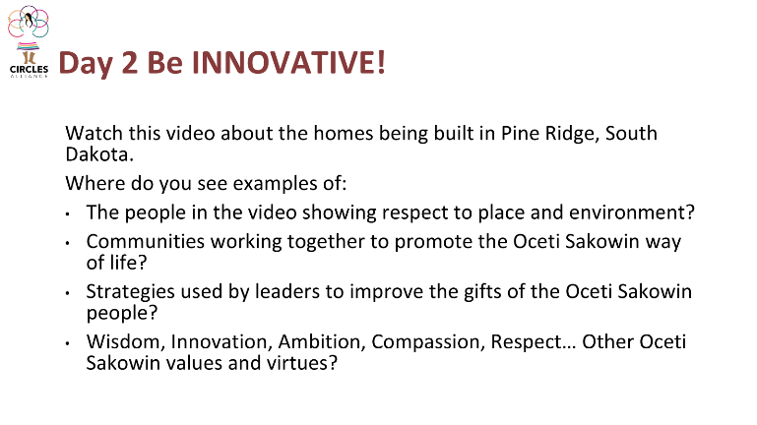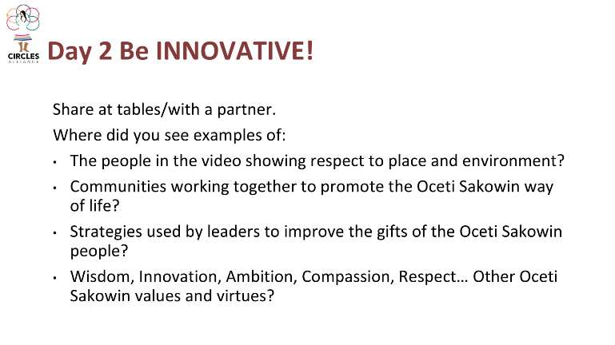
Have students share the examples they found in the video with a partner or small group. As with the day before, teachers can listen to small groups and ask students if they might feel comfortable sharing with the whole class.
After providing time for students to share in small groups, ask if anyone would like to share with the class. Teachers can build up this conversation with other key observations from the video.
Provide students with one or two more minutes to reflect on their building task, and how they will be sure to practice community in their building process,

Explore
Provide students with their base, a 6 inch by 6-inch piece of cardboard. Allow students to build their shelter using the materials provided, problem solving as they proceed.

After about 15 minutes, have each group identify a “traveler” (person that most recently before the workshop traveled out of state). The traveler checks in with each of the other groups for ideas and reports back to their home group. Travelers may ask questions about the materials, their purpose and any building challenges.

Students will have the entire period to complete their design.

Provide 10 minutes at the end of class for teams to pick up and reflect on how they helped their team for the day:

Closure day 2: Exit ticket
Have students reflect on ODEU 7 Way of Life and Philosophy.
Have students reflect on how they contributed to the construction of their home.

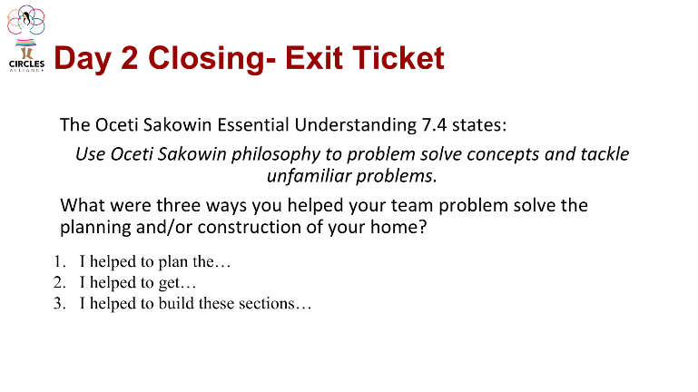

Day 3- Test
Preparations before class:
Set out the testing procedure supplies. Like you did with the building materials, these can be displayed on a table for student use.
Opener: Warm up- Display the warm up slide as students come into class.
Have students gather their homes AND review their testing procedure they were given day the first day of the lesson.
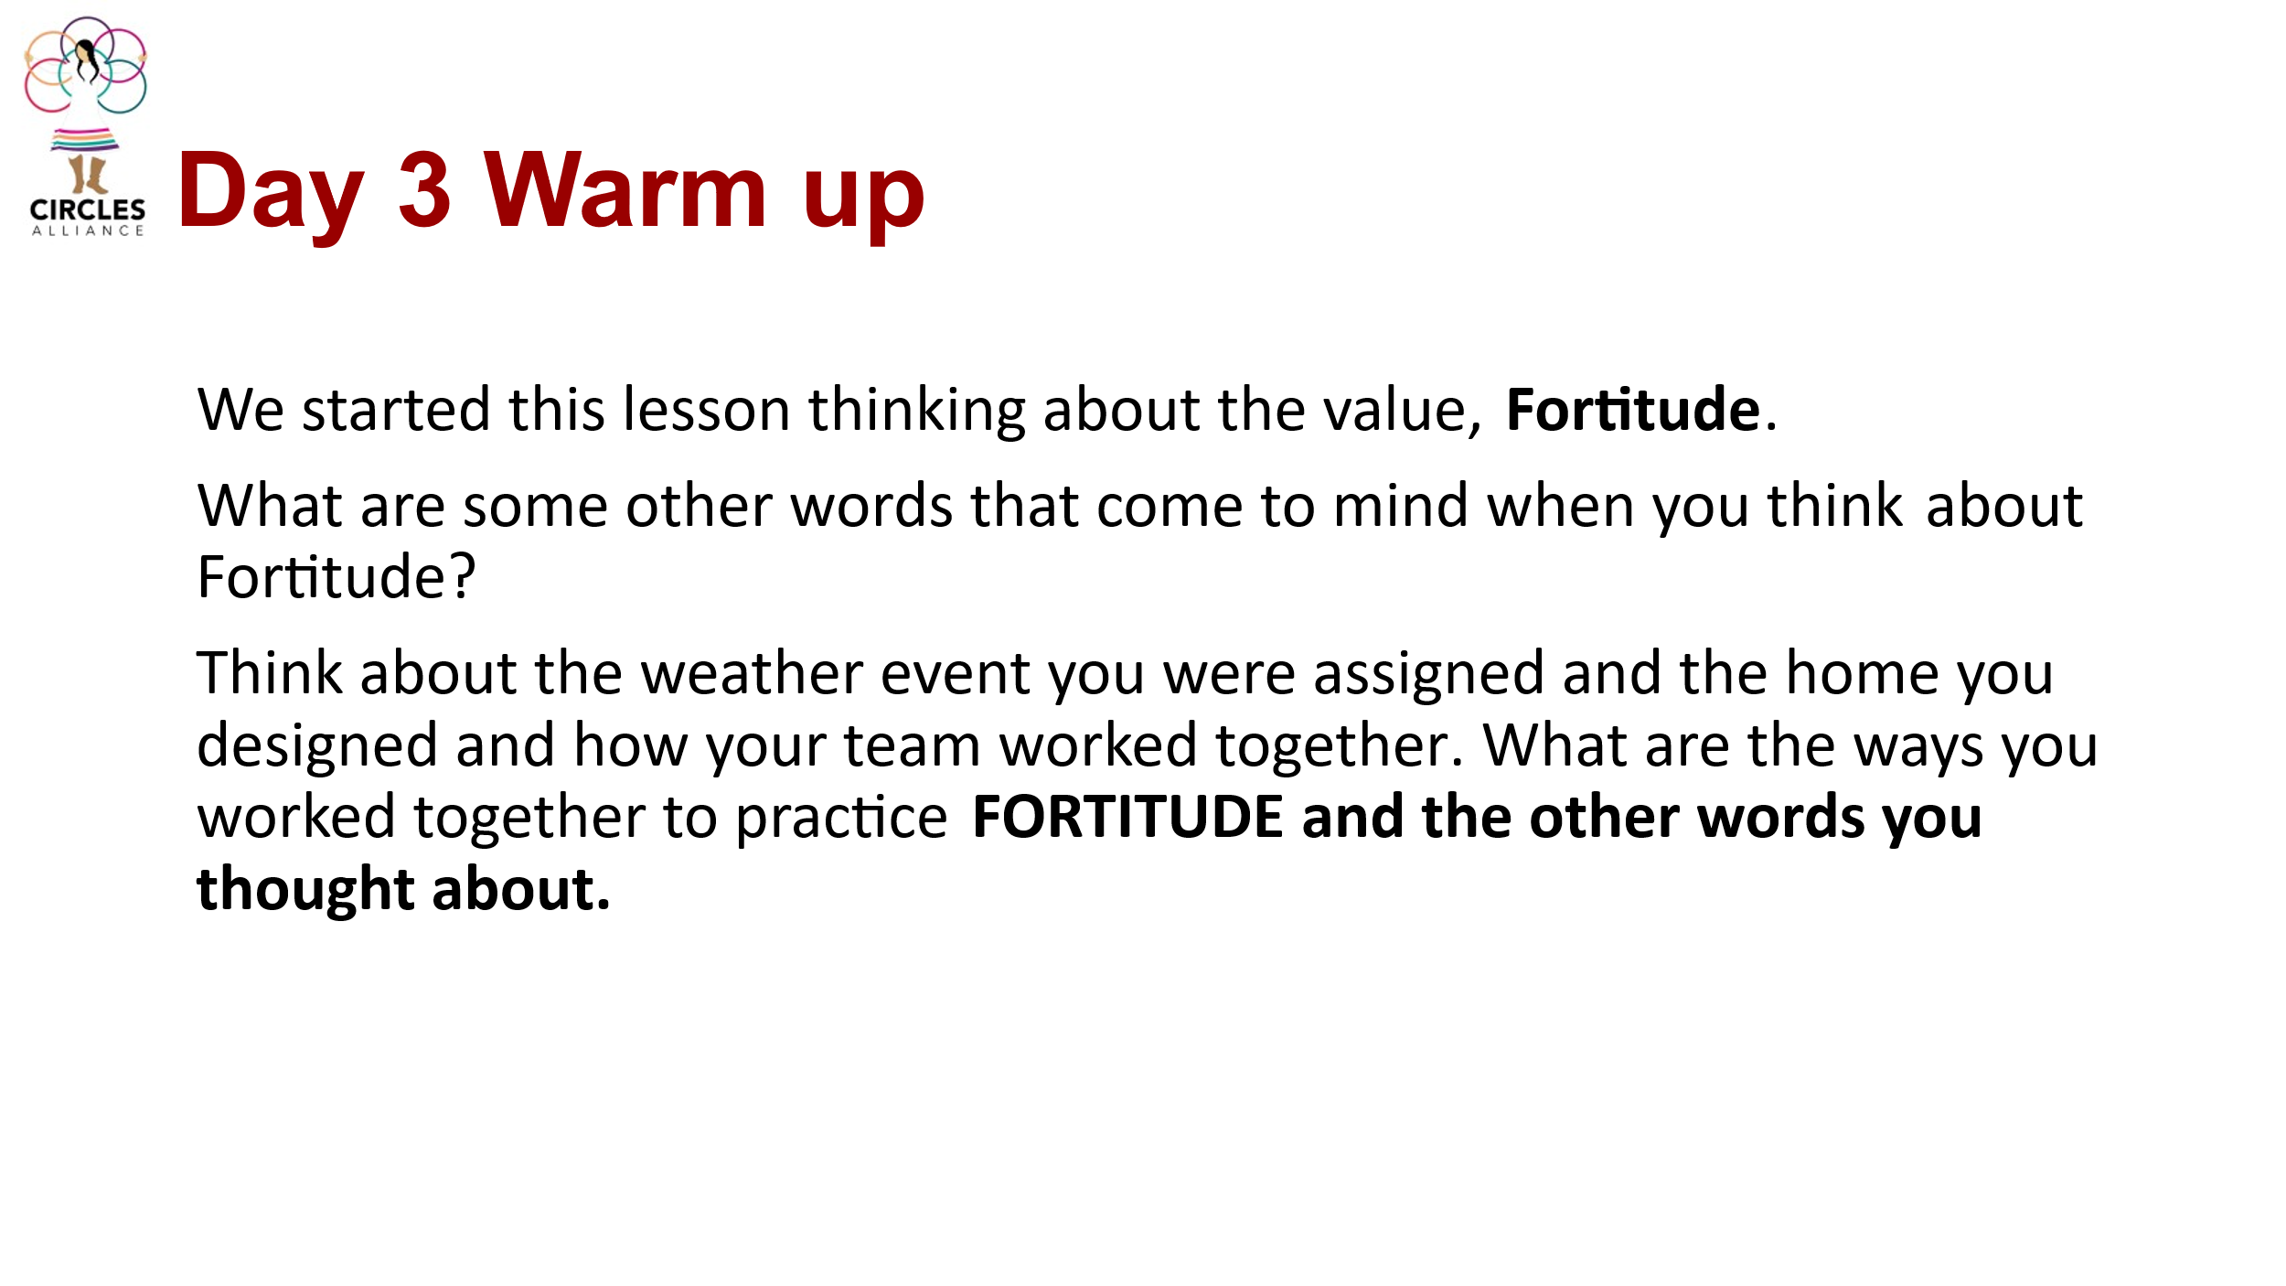

Give students time to think about these questions as they walk into class.
Allow time for students to share their responses before they gather their testing materials.

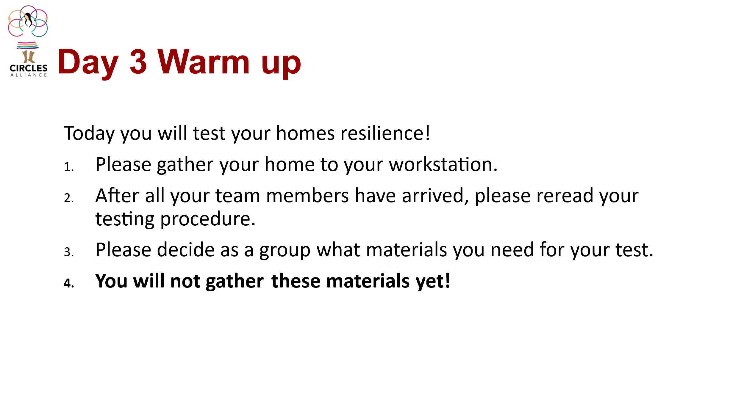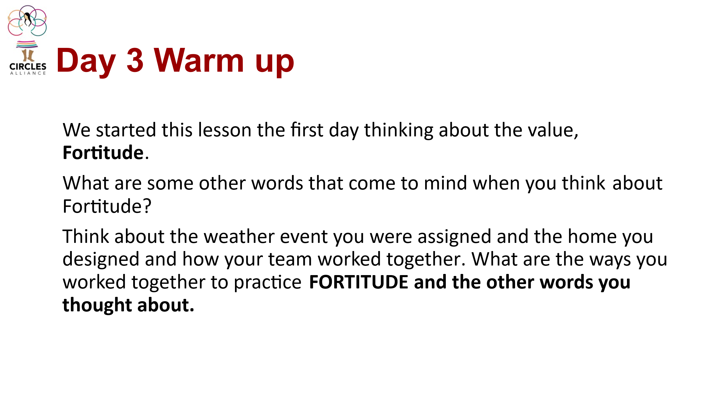
Provide students with about 10 minutes at the start of class to gather the supplies they need for their test- BUT NOT TO TEST! Teams will also use this time to prepare their short presentation to include: Their assigned weather event, plans, building materials and testing procedure.

Sharing the Results:
Have each team share its design, testing results and implications for future design. Sharing these results will be a class gallery walk.
Presenting teams: Share their weather event, the plan they designed- and why, the materials they used- and why, and test the resilience of their home.
As teams present, students will travel around to each group and observe the testing. Observers do not contribute comments–they simply enjoy the tests.

All testing procedures are listed below- but the Blizzard team has special instructions.

**Blizzard group**

After this team presents their weather event, design plan, build and testing procedure they will record the inside temperature of their shelter AND place the heat lamp inside their shelter. (Let the class know this test is a bit of work for this group to get set up and stay patient). Then have them record and share with the class the inside and outside temperature of their shelter. And turn on their heat lamp.
During their test the class will watch the linked video: How Native Americans Stayed Warm in Tipis During Freezing Nights?
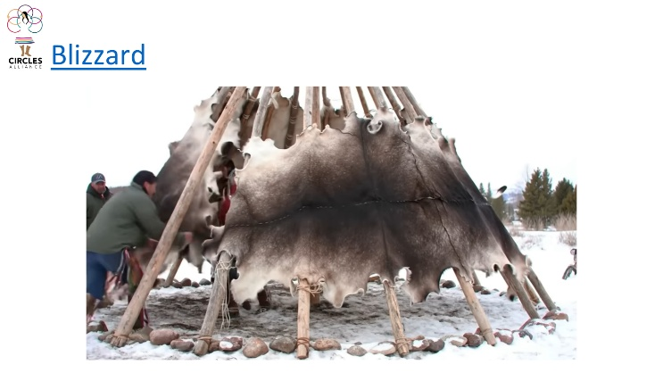
Pause the video at #4- Animal Skins.
Ask the blizzard team to test, record and share the temperature inside and outside their home. AND turn the heat lamp off.
Resume the video and watch until the end. (this does not give the full 10 minutes) Ask teams to test, record and share the temperature inside and outside their home one more time at this point.
You may choose to have another team present and have this team test the temperature one additional time.

Testing Procedures:
#1 Flood: Place each shelter inside a plastic container. Use 150 mL. of water to flood the small container, pouring water near the side of the shelter, thus flooding the plastic container. The team makes observations and evaluates how their structure held up against the flood using the Testing Results chart.
#2 Tornado: Use a vacuum cleaner ‘arm’ to simulate a tornado and a blow dryer to simulate high winds. Simultaneously hold the vacuum cleaner and the blow dryer above the structure and circle around the structure five times. The team makes observations and evaluates how their structure held up against the tornado using the Testing Results chart.
#3 Mudslide: Use 3 cups of runny mud and gravel, and a 1 foot x 1 foot piece of cardboard. Place the piece of cardboard at an angle against an outside wall. Put the structure at the bottom of the piece of cardboard on the ground. Spill the mud onto the cardboard and let it roll down to the structure hitting its side. Make sure the mud is thick enough to have an impact, but thin enough to slide down the cardboard incline. Have the team make observations and evaluate how their structure held up against the mudslide using the Testing Results chart.
#4 Blizzard: Test the inside temperature of the shelter to keep the inhabitants from freezing. Place a thermometer inside and outside the shelter. Place a heat lamp inside the shelter with an opening for the electrical cord to slip through. Record the initial temperature inside and outside the shelter. Turn on the heat lamp. Record the time and temperatures after 5 minutes. Turn the lamp off and take the temperatures again after 10 min. (after break) Have the team make observations and evaluate how their structure held up against the cold temperatures using the Testing Results chart.
#5: Hail: Test the shelter’s resistance to hail by pouring “heavy rain” from a watering can and by forcefully dropping clay balls, ball bearings, frozen peas and ice cubes on the shelter. The team makes observations and evaluates how their structure held up against the hail using the Testing Results chart.

Debrief/Activity closure:
Provide students with the Testing Results Recording Page.

Students will have 10 minutes to record their weather event, draw a sketch of their house, and reflect and add ideas how they might edit their design for improvement.
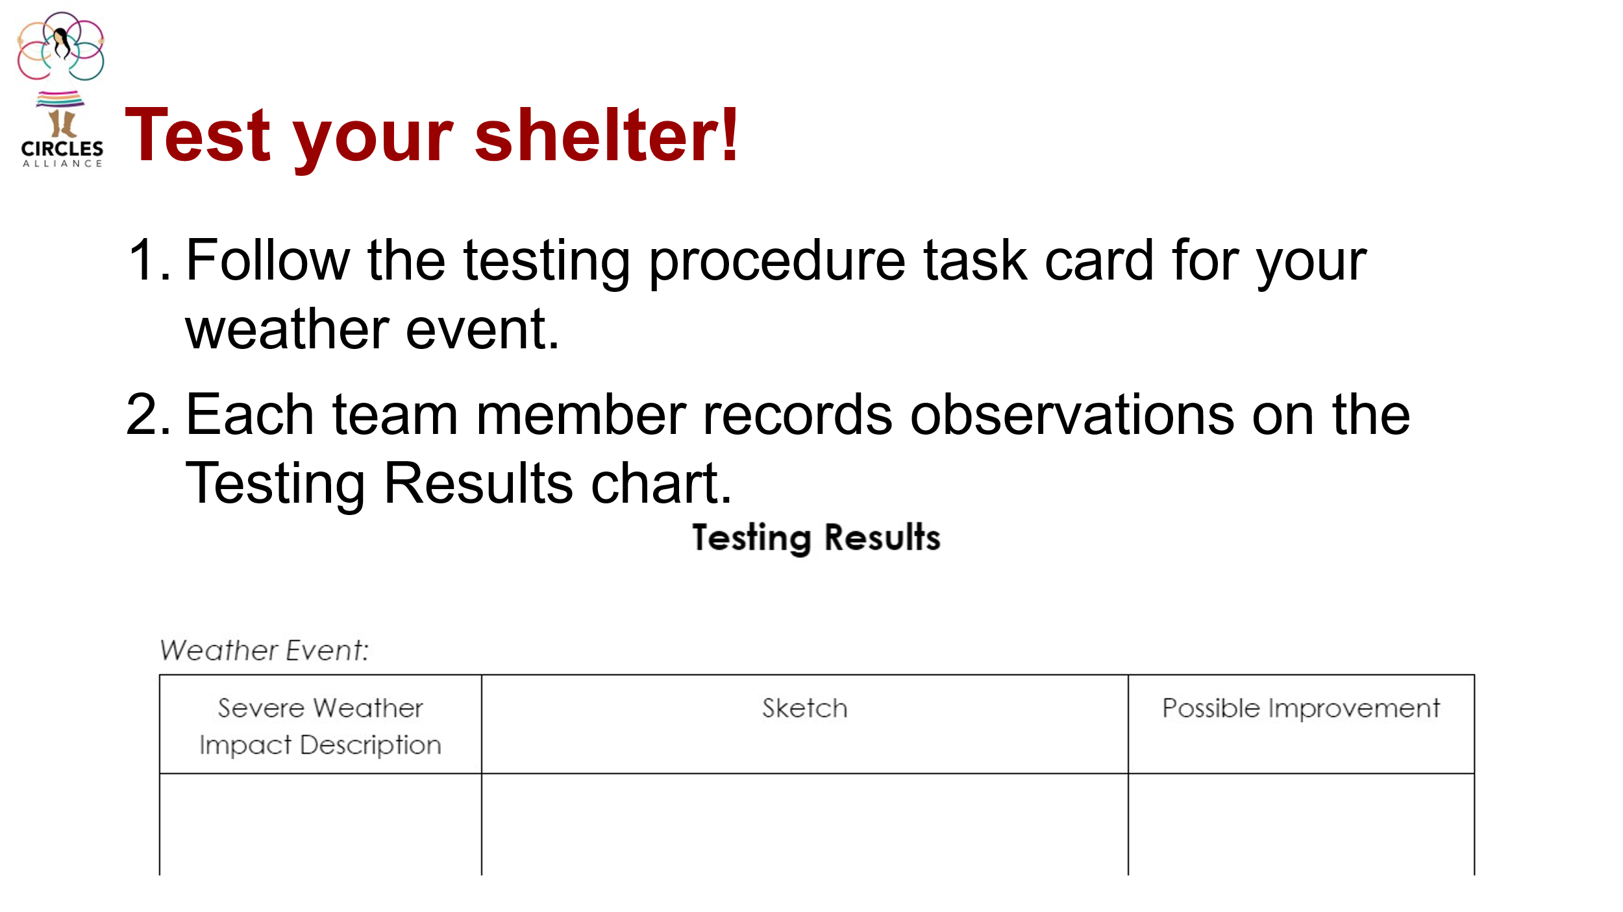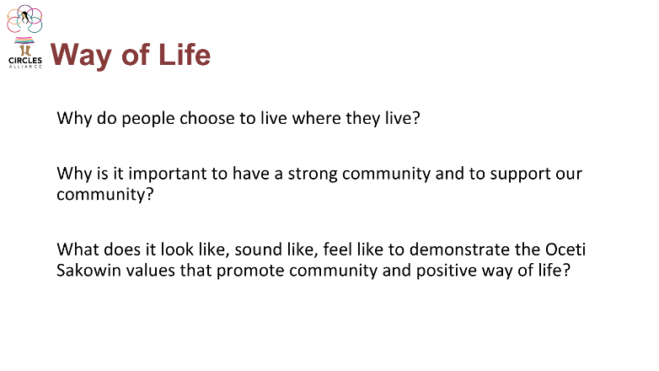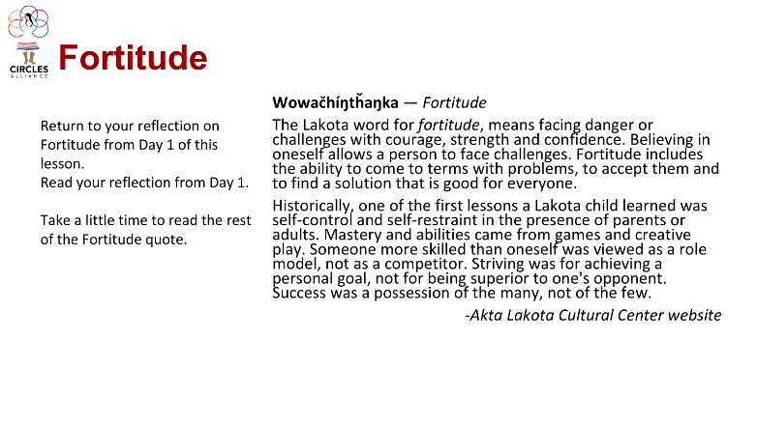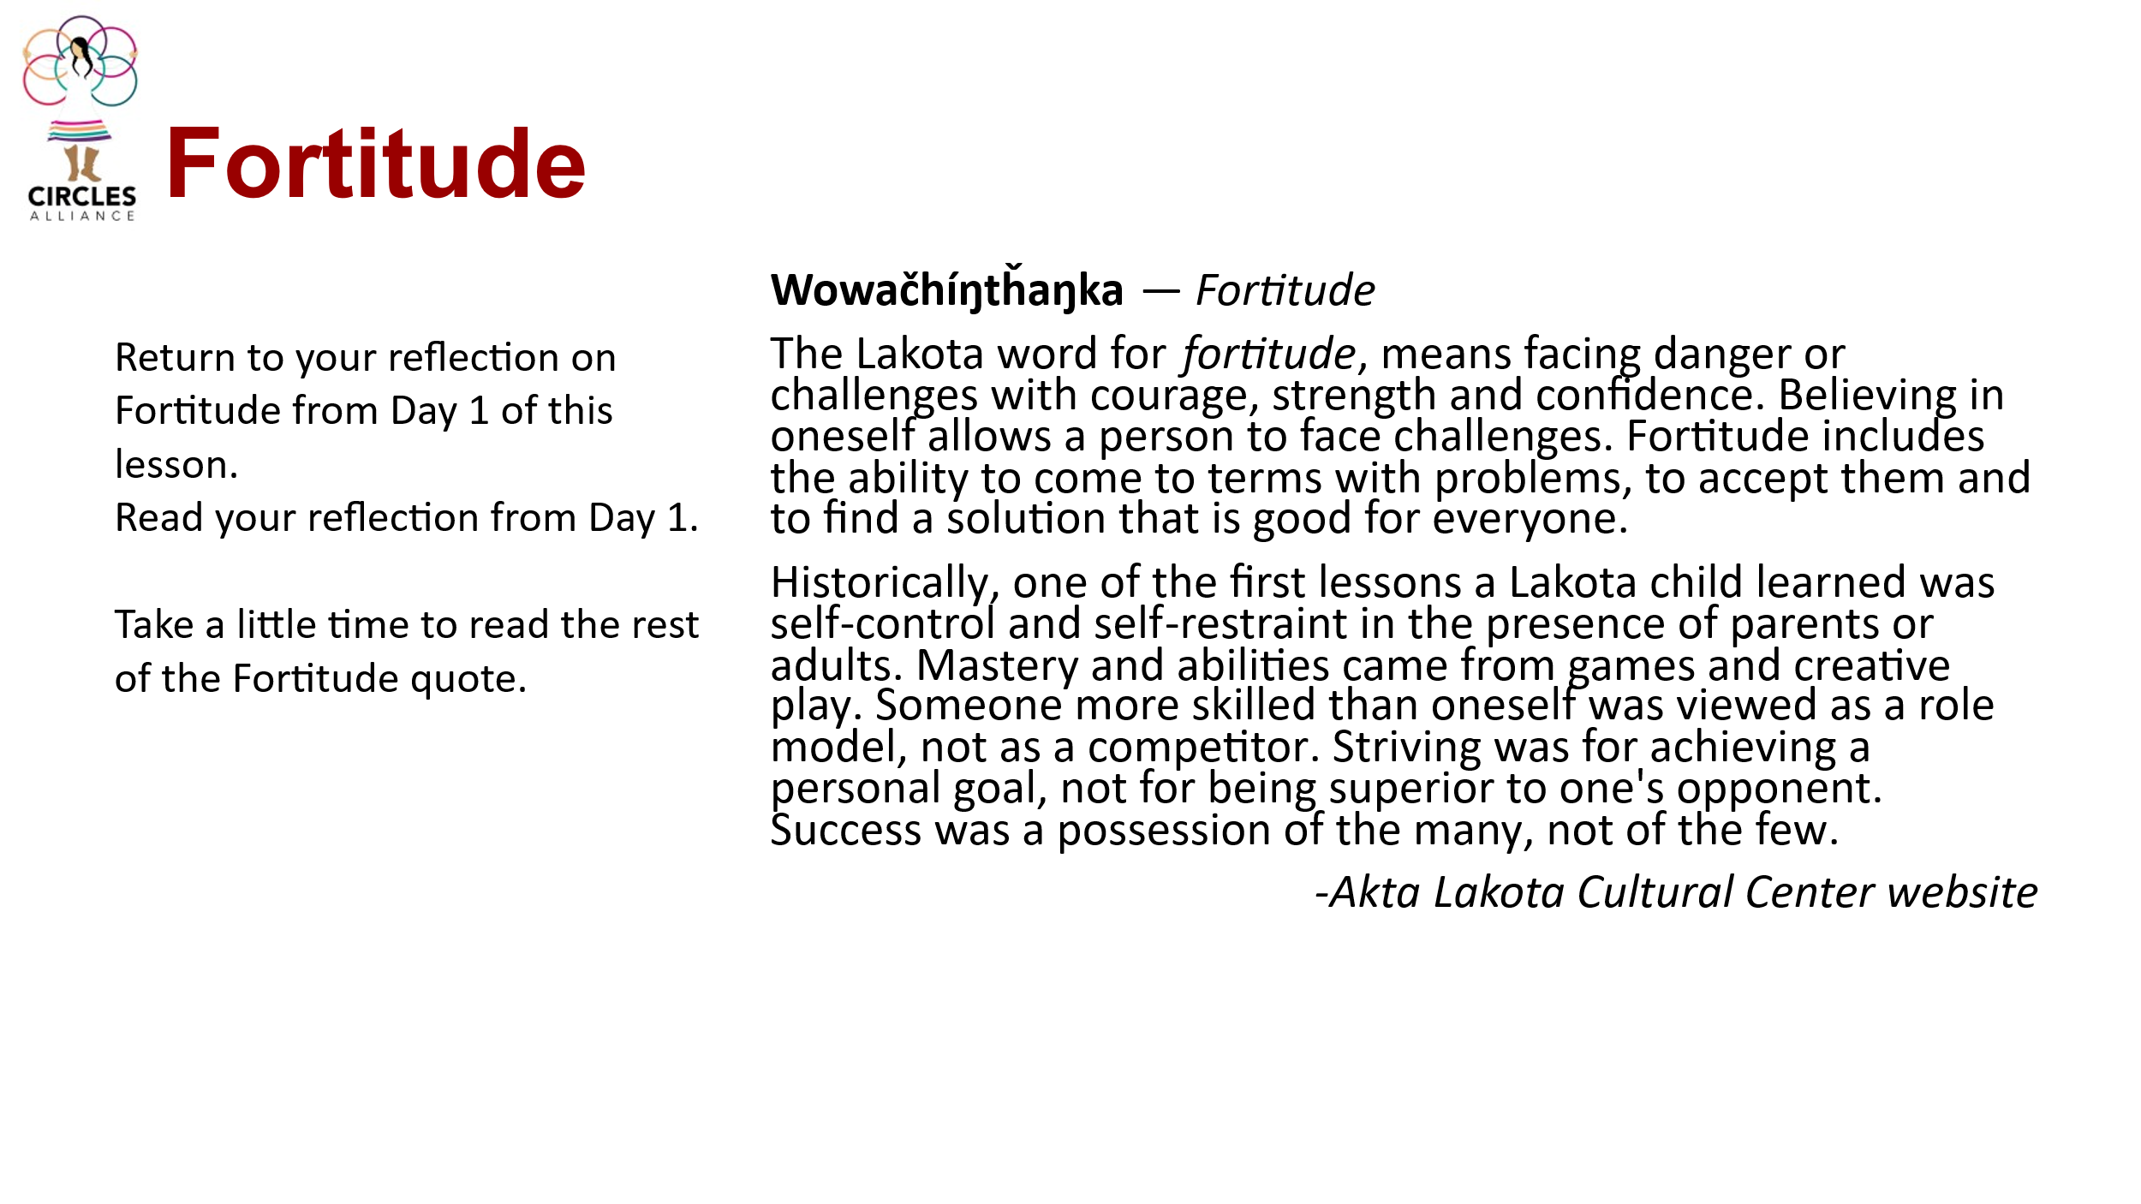
This is a good time to have a discussion with students about the weather events of South Dakota. Ask students, knowing that these weather events occur and we have to make special adjustments to our homes to withstand weather conditions, why do people continue to live where they live?
Students may respond with things like, there family is nearby, they don’t want to leave their community, all places you live have challenges.
Then ask, why is it important to have a strong community when faced with challenging weather events?
Students may respond with phrases like, to support each other, to take care of those close by.
Remind students that the Oceti Sakowin Way of Life and Philosophy is grounded in the values of the people and the idea of supporting community for the good of everyone. And that the students as the generation to follow need to remember they are also a part of this community, to help one another and support their communities.

Then, return to the fortitude quote and the new Joseph Marshall quotes.
- Have students return to their notebooks where they reflected on the fortitude quote on day 1.
- Have students take about 5 minutes to add to this reflection any new ideas/learning they have about fortitude.
After your new learning, what other thoughts do you have about me fortitude, resilience, and problem-solving? Have they changed?
Students can add this to their notebooks.

Optional extension (s):
The Lakota Way written by Joseph Marshall III includes a chapter on Fortitude. If time allows this chapter could be a class read aloud- with further reflection on the actions that demonstrate fortitude in each of the stories.

To turn this into a longer lesson (4 days)- If time allows, have students research historic home structures that survived prairie weather events that may benefit their assigned weather event. This could be done on day 1 prior to students creating a plan. Examples may include Tipis, earthen lodges, log homes, clay/mud homes.

